Ideation phase
Brainstorming & idea prioritization template.
(Phase-1)
Date | 1th November 2025
Team ID | NM2025TMID07796
Project name | Optimizing user group &role management with access control and workflows
Maximum marks | 100 marks
Title theme:
This title is about improving how users are organized, assigned roles, and given permissions in a system — so that security and efficiency are both strong.
- User Group Management → Grouping users (e.g., Admins, Managers, Employees).
- Role Management → Assigning what each group can do (e.g., Admin can add users, Employee can view only).
- Access Control → Setting clear permissions: who can access what (files, features, data).
- Optimization → Making the whole process faster, simpler, and more secure — reducing errors, duplication, and unauthorized access.
Golden rules for great ideas:
Rule:
What is mean for our service now project
Volume over value:
The system should be able to handle high user volume (many users and roles) while maintaining quick access control, permissions, and role assignments without slowing performance.

Example:
Automating role assignments for 10,000+ users instead of manually approving a few users at a time.
Definition:
Focusing on managing a large number of users and groups efficiently rather than handling only high-value or limited users.

Using the idea template:
An Idea Template in ServiceNow is a structured format used to capture, organize, and evaluate new ideas or improvement suggestions within an organization. It serves as a standardized framework for users to submit ideas related to process enhancement, automation, innovation, or service improvement.

This template helps ensure that every idea is documented with key details— such as the problem statement, proposed solution, business impact, and effort required—making it easier for review teams to analyze, prioritize, and implement the most valuable ideas using the ServiceNow Idea Management module.

team gathering, collaboration & select the problem statement.
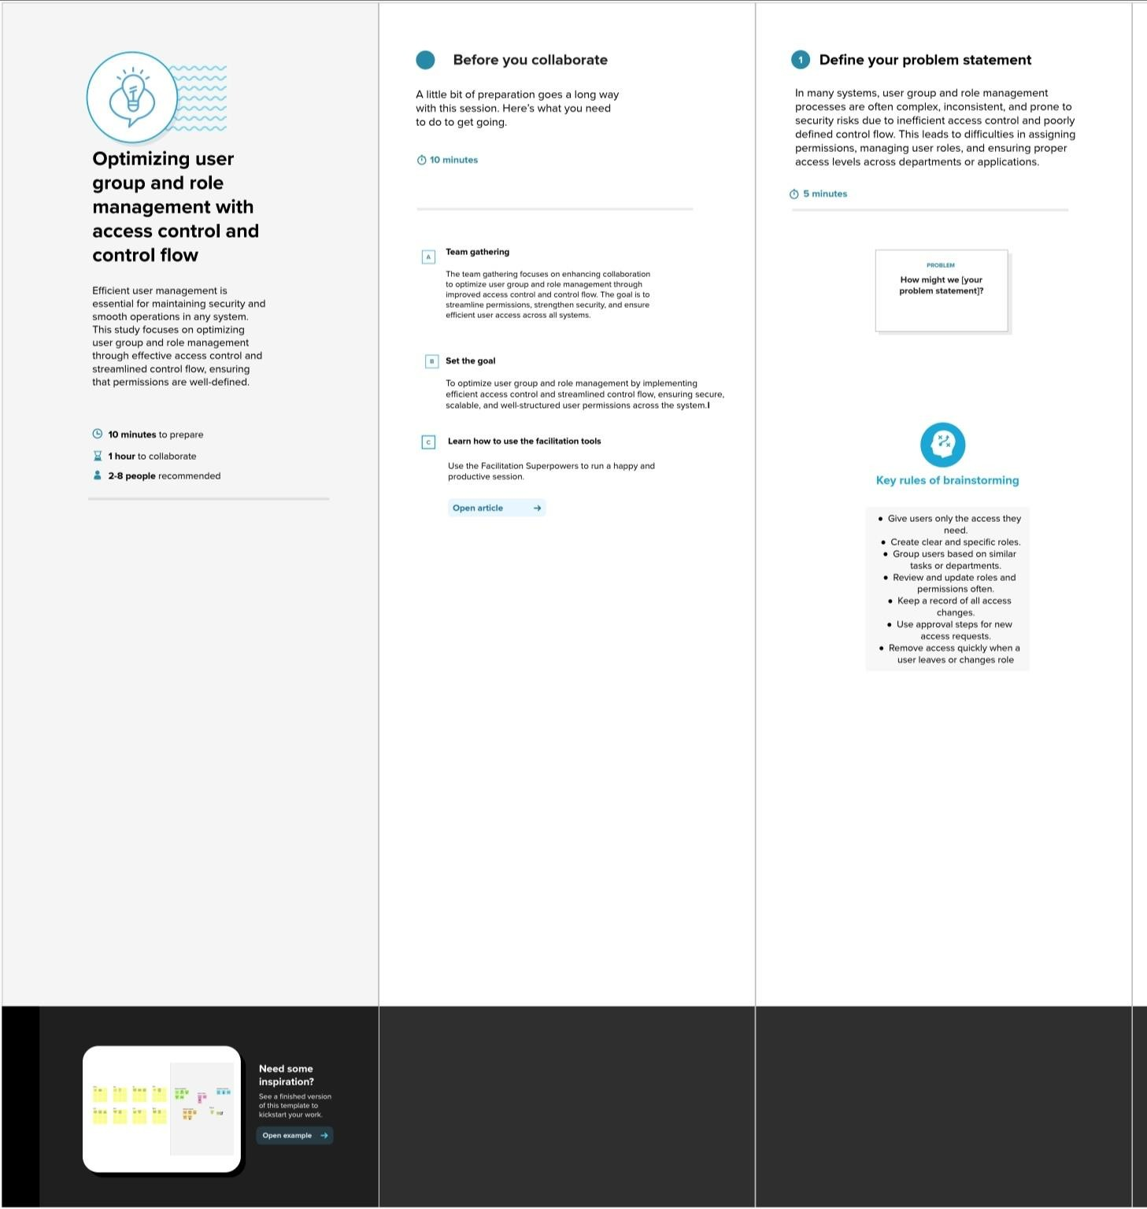

group idea, brainstorming.
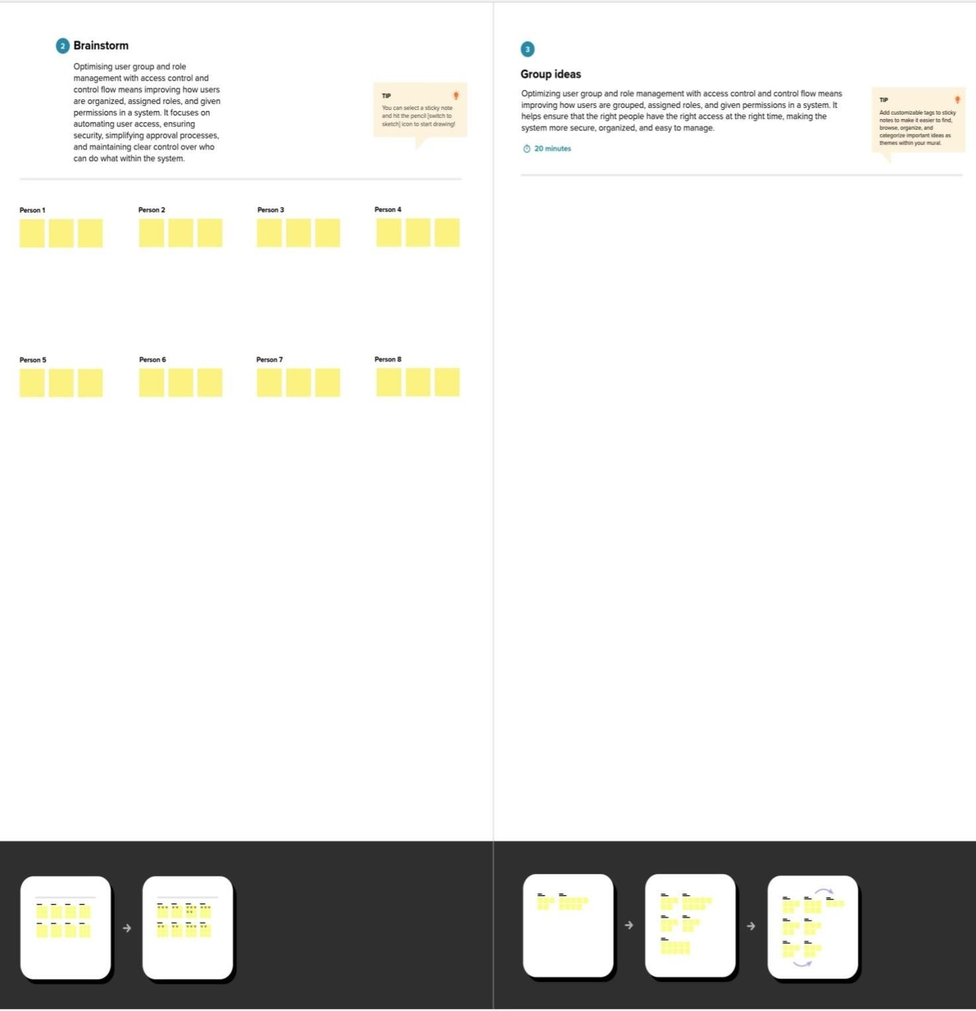

prioritize
